

Project Design Phase
Problem - Solution Fit Template

Date | 15 July 2026
Team ID | SWTID-2026-7507
Project Name | DarshanEase - Temple Darshan Ticket Booking App
Maximum Marks | 2 Marks

Problem - Solution Fit Canvas: DarshanEase
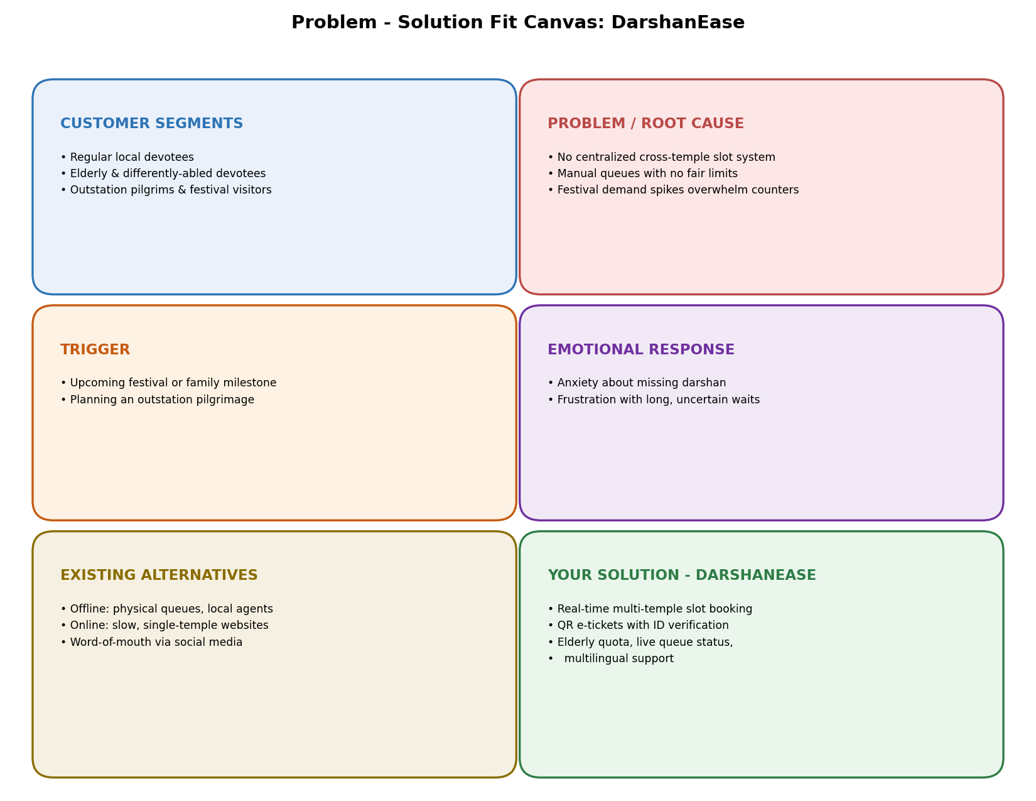
Canvas Detail:
Customer Segments  • Regular local devotees visiting for daily/weekly darshan  • Elderly and differently-abled devotees  • Outstation pilgrims and tourists visiting for festivals  • Devotees booking special poojas/sevas for occasions | Problem / Root Cause  • No centralized system to check slot availability across temples  • Manual, first-come-first-served queues with no fair limits  • Sudden demand spikes during festivals overwhelm counters  • Lack of transparency leads to touting by unofficial agents
Trigger  • An upcoming festival, special pooja, or family milestone  • Planning an outstation pilgrimage trip in advance  • Wanting to avoid long physical queues on the visit day | Emotional Response  • Anxiety about missing darshan despite travelling far  • Frustration with long, uncertain waiting times  • Stress from last-minute, unplanned booking
Existing Alternatives (Online & Offline)  • Offline: standing in physical queues, calling temple offices  • Offline: relying on local agents/touts for quicker access  • Online: individual temple websites that are slow or unreliable  • Online: word-of-mouth via social media/community groups | Your Solution - DarshanEase  • Unified app for real-time slot booking across multiple temples  • QR-code based, ID-verified e-tickets to prevent touting  • Special quota and assisted booking for elderly/differently-abled  • Multilingual interface and live queue/wait-time status

